**ASSIGNMENT 9.2**

PROBLEM STATEMENT:

1) **Create an HBase table named 'clicks' with a column family 'hits' such that it should be able to store last 5 values of qualifiers inside 'hits' column family.**

Solutions:

In the above question I have created a table in hbase as ‘soham1’ instead of clicks’ and column family as ‘address’ instead of hits. So, the output is given below.

Output:

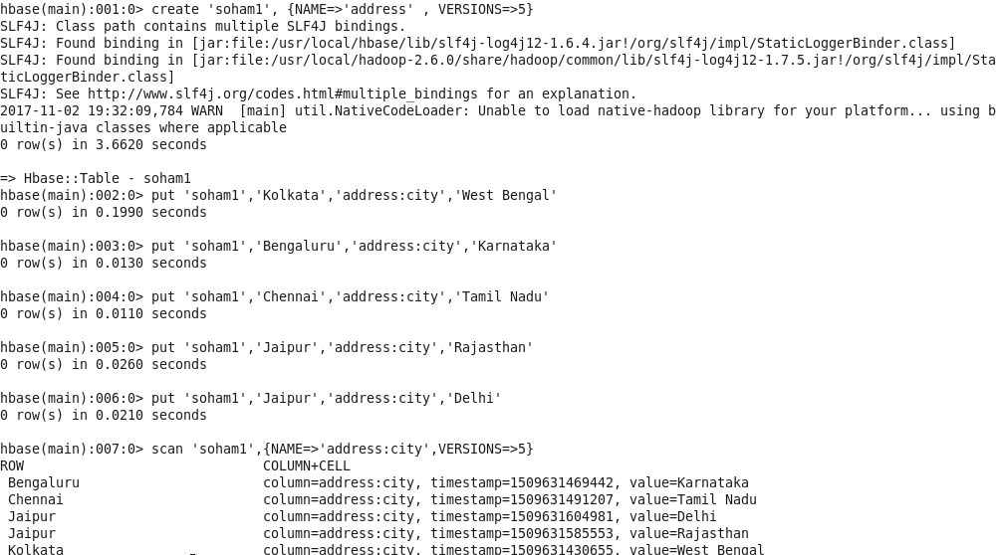

2) **Add few records in the table and update some of them. Use IP Address as row-key. Scan the table to view if all the previous versions are getting displayed.**

Solutions:

Here in the above question we have created a table and add some values where row-key is IP address but I have mentioned as address in the code and column family: column Name is hits: values. The output is given in below.

Output:

